Create And Configure IBM Cloud Service Create A Database in Cloudant DB

|  |  |
| --- | --- |
| **Date** | **9 November ,2022** |
| **Team ID** | **PNT2022TMID12840** |
| **Project Name** | **lot Based Safety Gadget for Child Safety Monitoring & Notification** |
| **Maximum Marks** | **4 Marks** |

# AIM

To create a database in Cloudant DB to store location data

# STEPS

1. 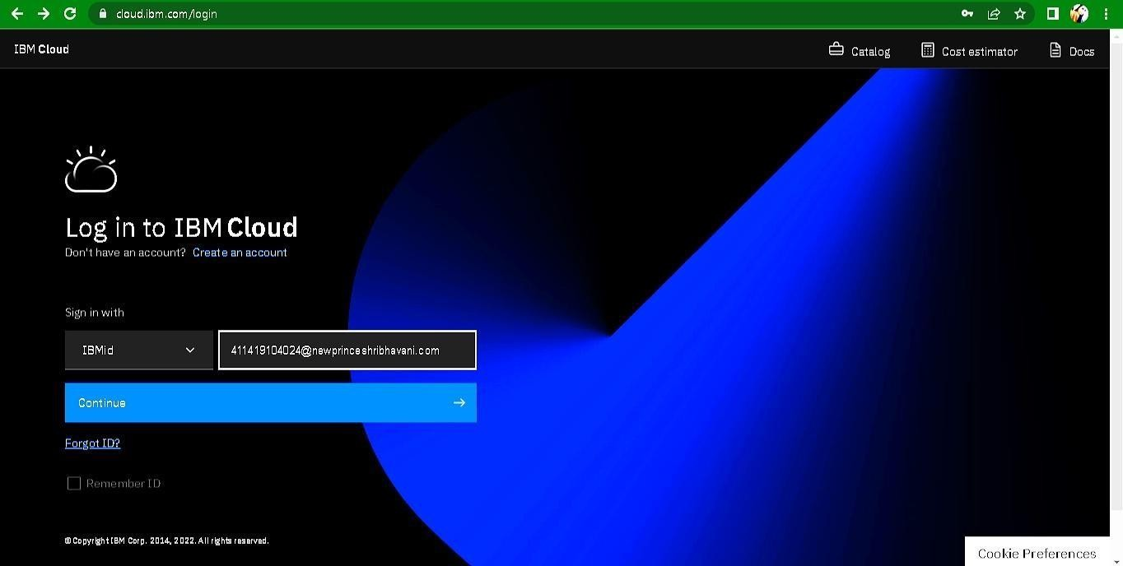Login to IBM Cloud with smart internz mail ID and Password.
2. Click “Create Resource +” button

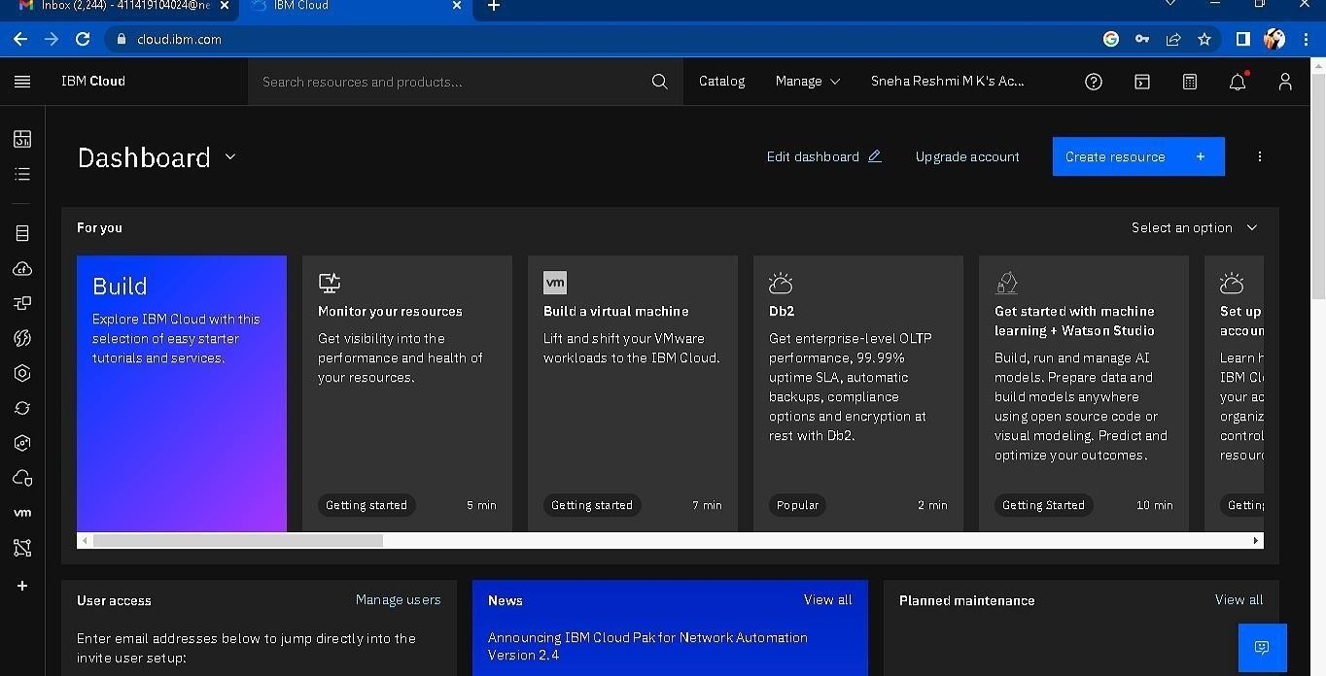

1. 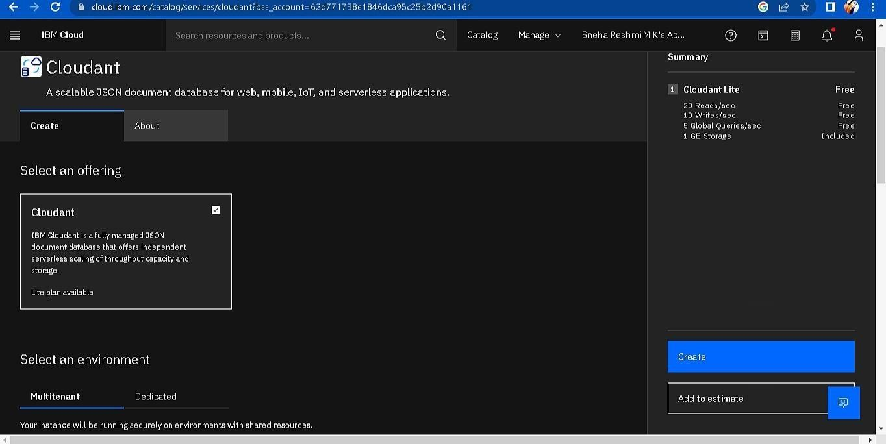Search Cloudant in Catalog then Choose the Lite version

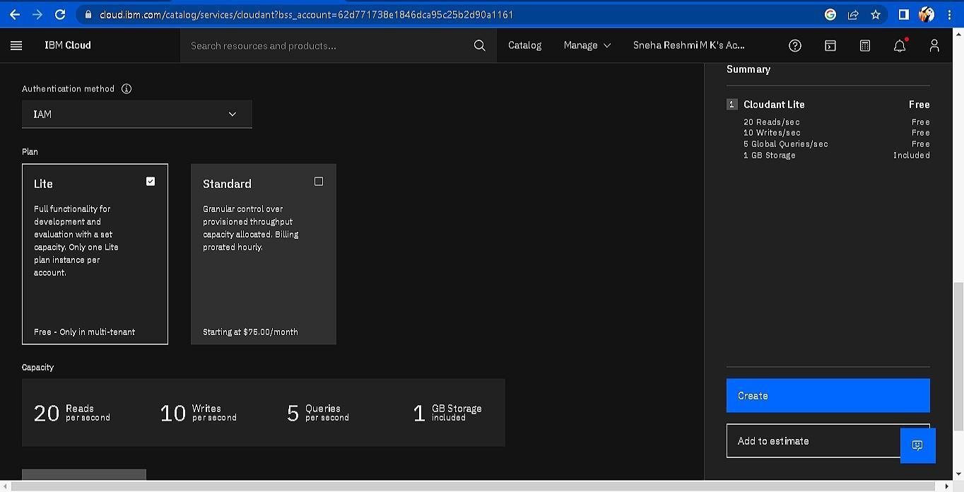

1. 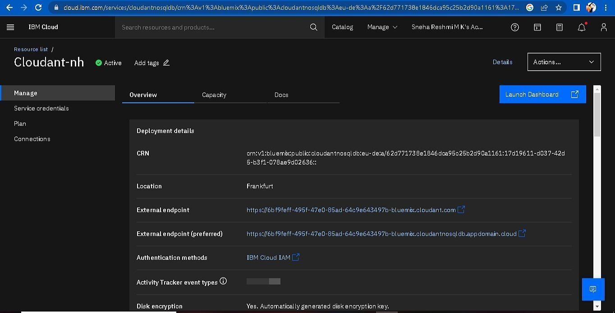The Cloudant database resource created
2. click on launch dashboard

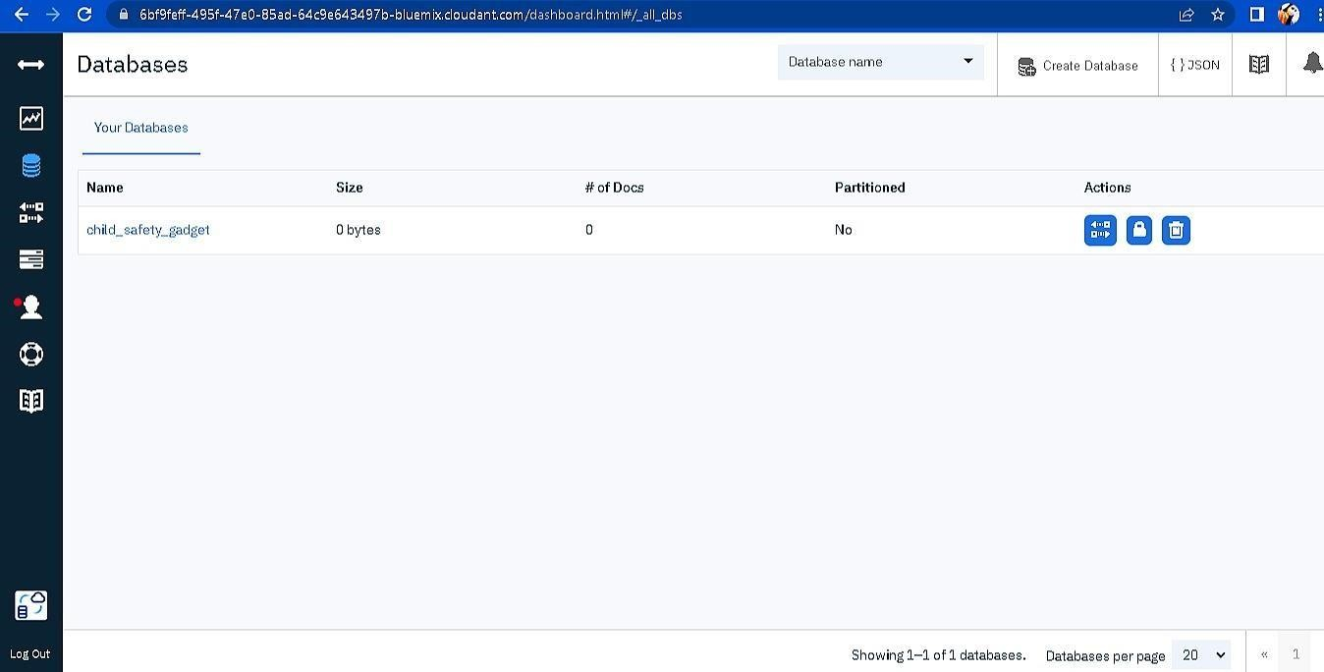

1. Click “Create Database”. Entered “child_safety_device” as the database name and the “Non-partitioned” option.
2. The database “child_safety_device” has been created and it's work Successfully

# RESULT:

A database to store the location data on Cloudant DataBase has been created successfully.